TASK 14:

* Learn about Azure File share
* Create an Azure File Share
* Mount the File Share on your local computer.

**Learning:**

**Azure file storage** is a service which allows you to mount your fileshare on local drive and it uses SMB protocol (Server Message Protocol) for accessing files.

**SMB protocol** is a client server communication protocol used for sharing access to files, printer, serial ports etc.

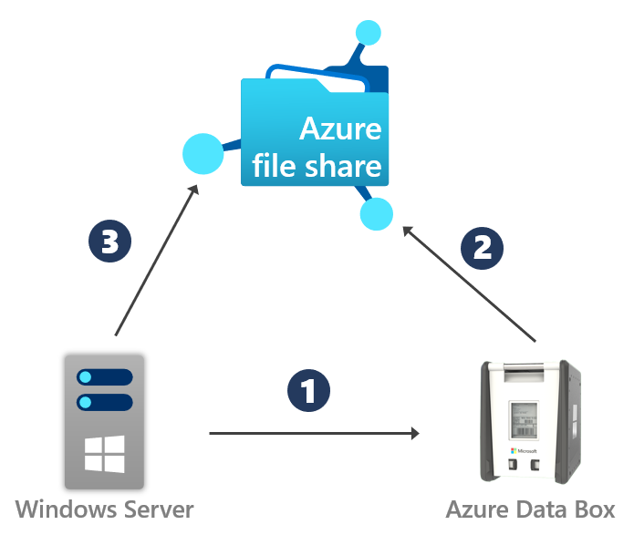

Azure File Share

Steps to create Azure file share and mount it on local drive:

Step 1: Open Storage account inside Azure portal and provide storage account name, region in which you want your storage account to deploy and other necessary details.

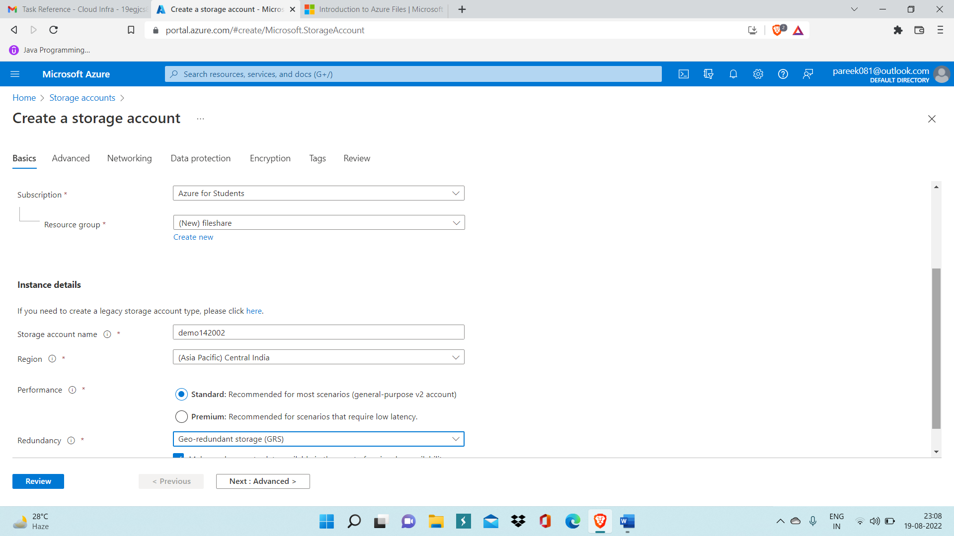

Step 2: Now after deployment, Go to Resources.

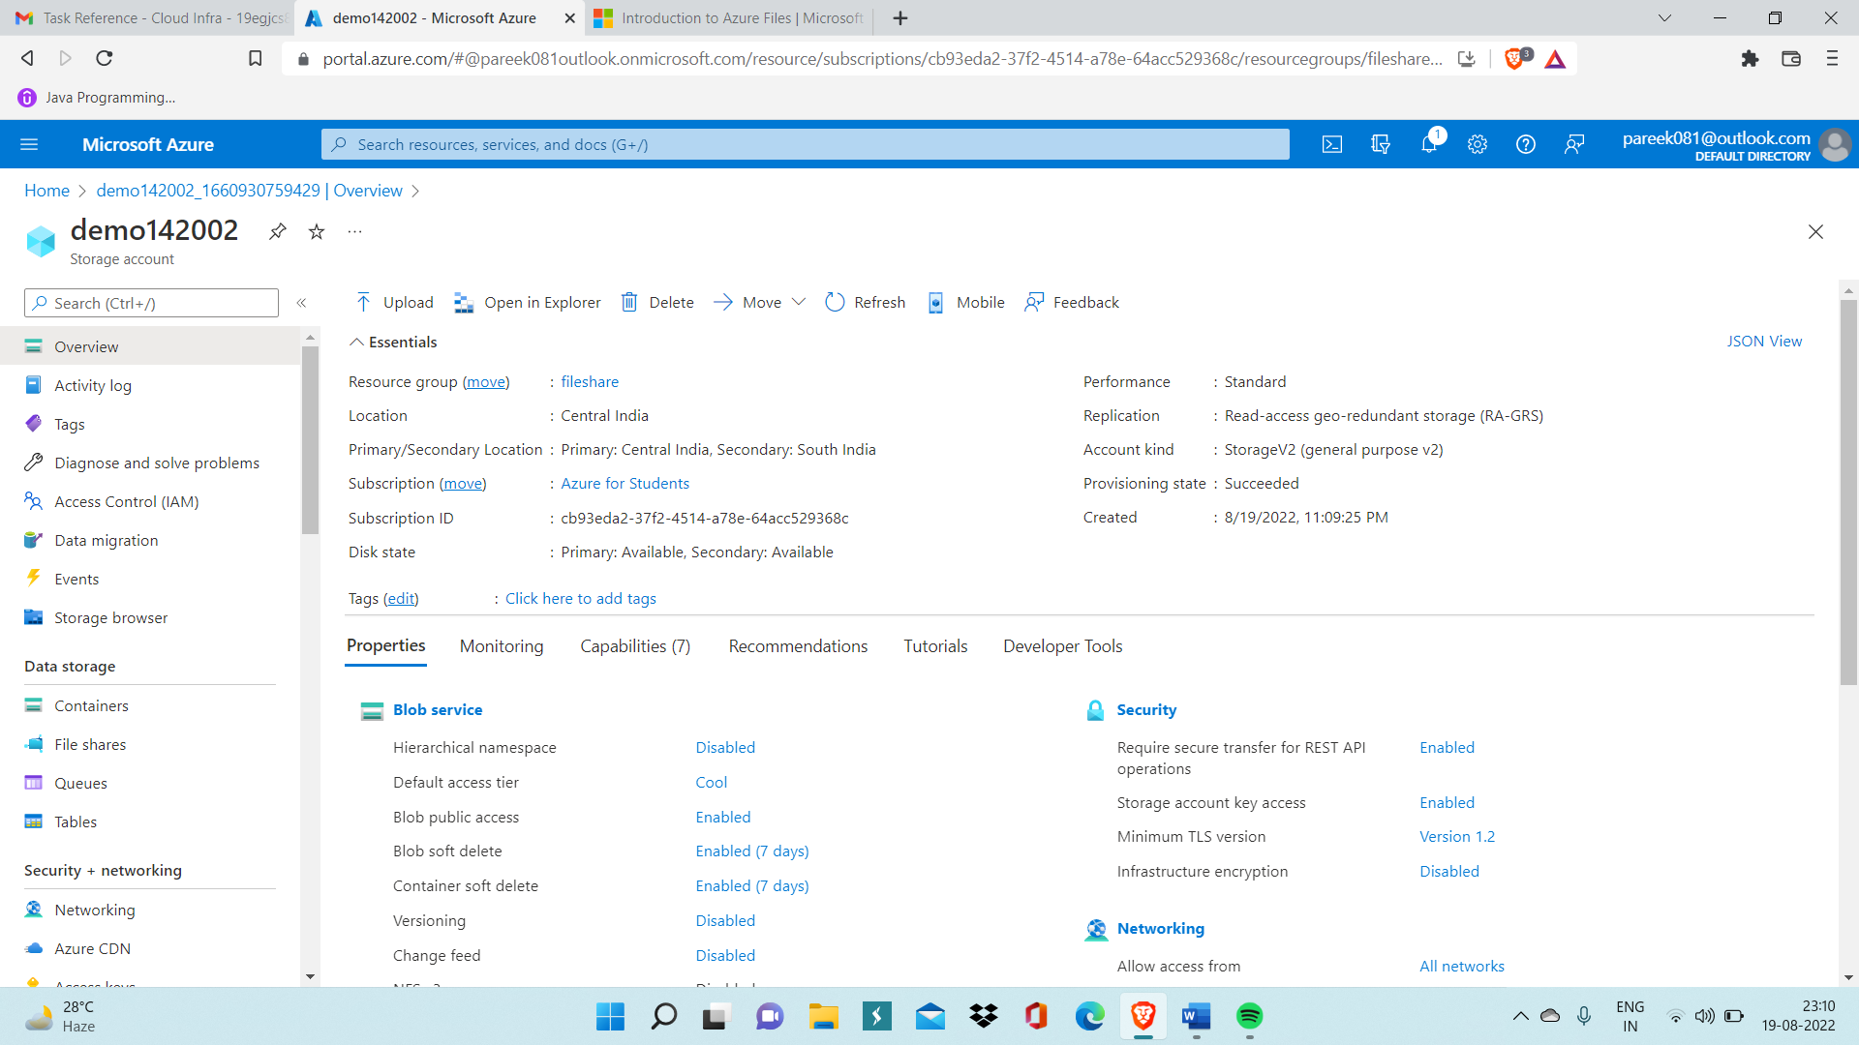

Step 3: Now Go inside File Share data storage service.

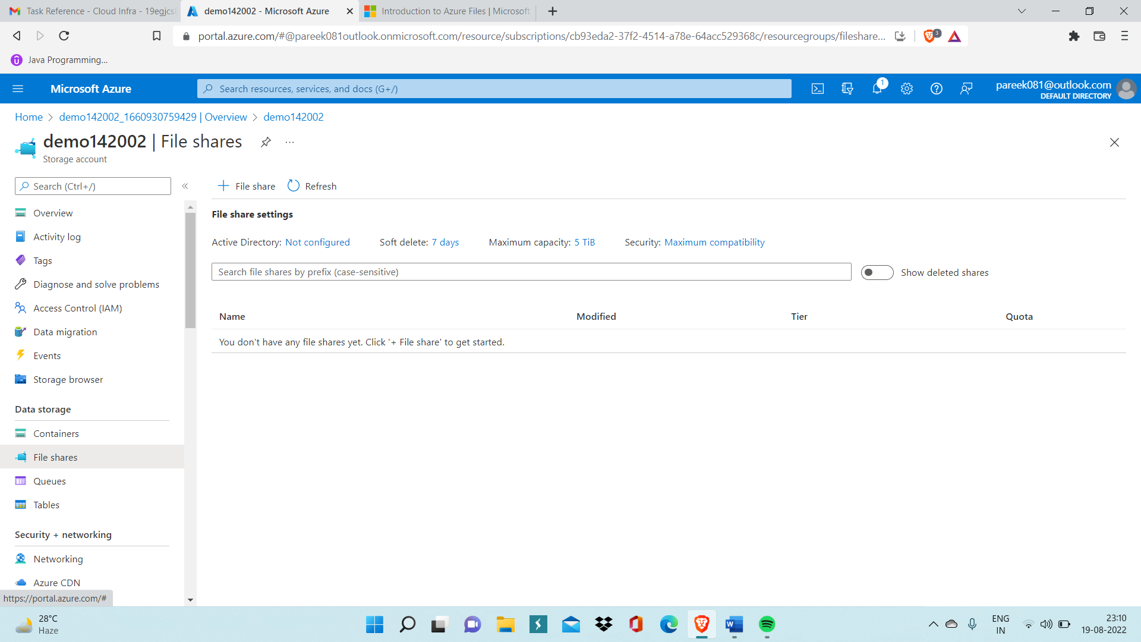

Step 4: Click on Add File Share and write file name and then click on Create.

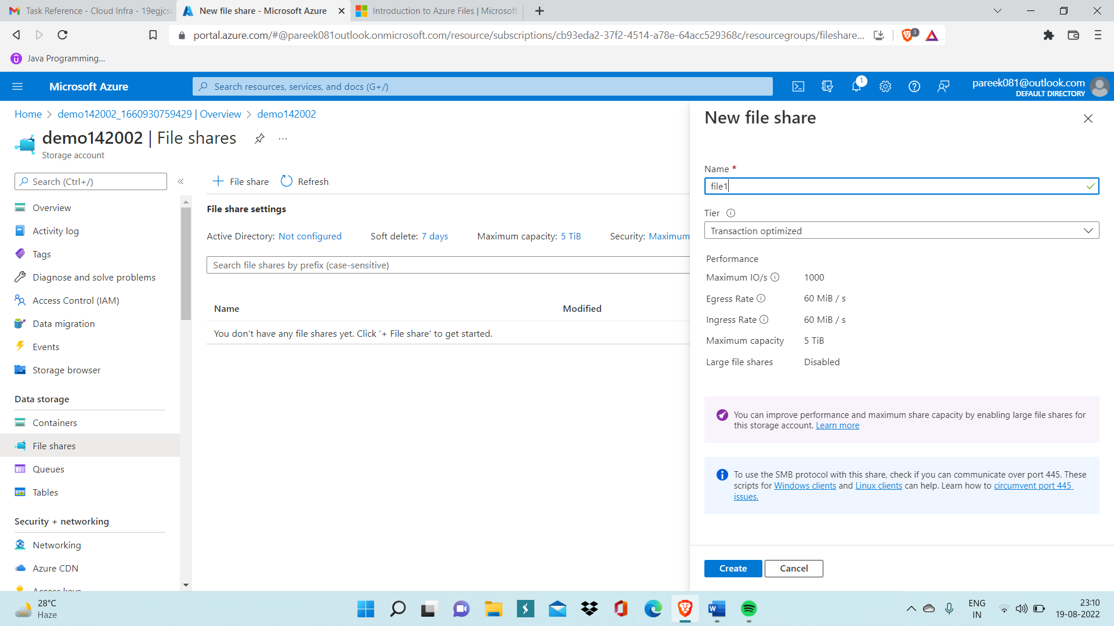

Step 5: Now, open fileshare you created namely ‘file1’, then, click on Connect and copy Storage account key and paste it on powershell window of your local computer.

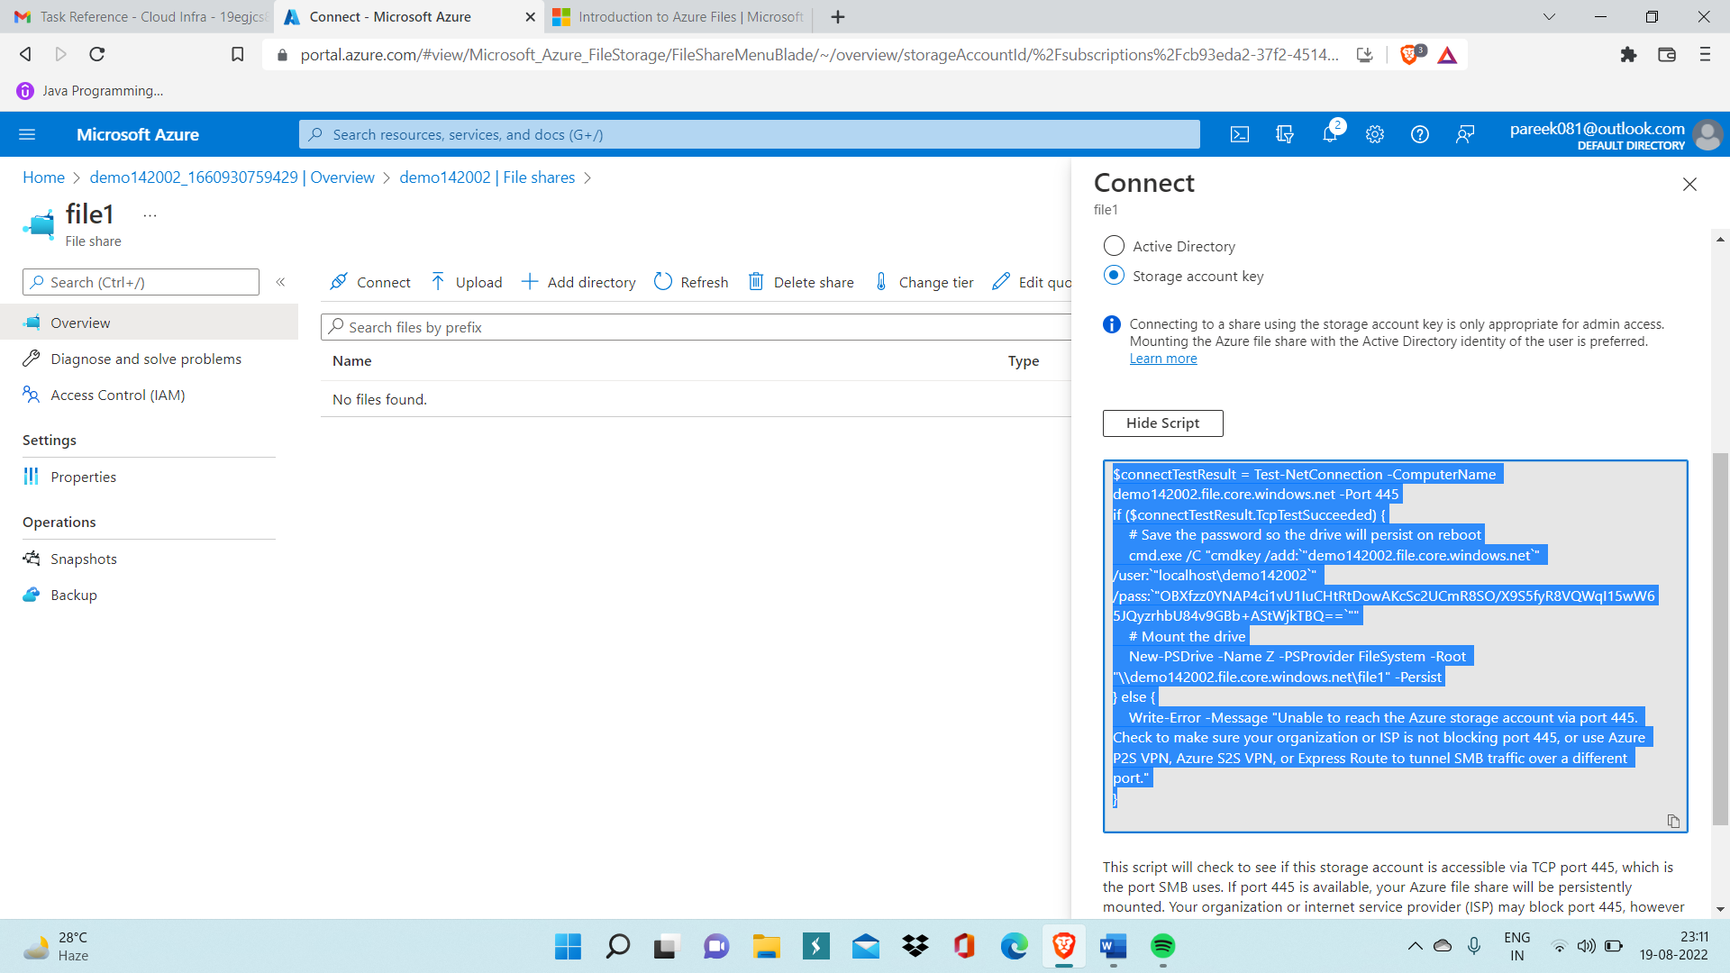

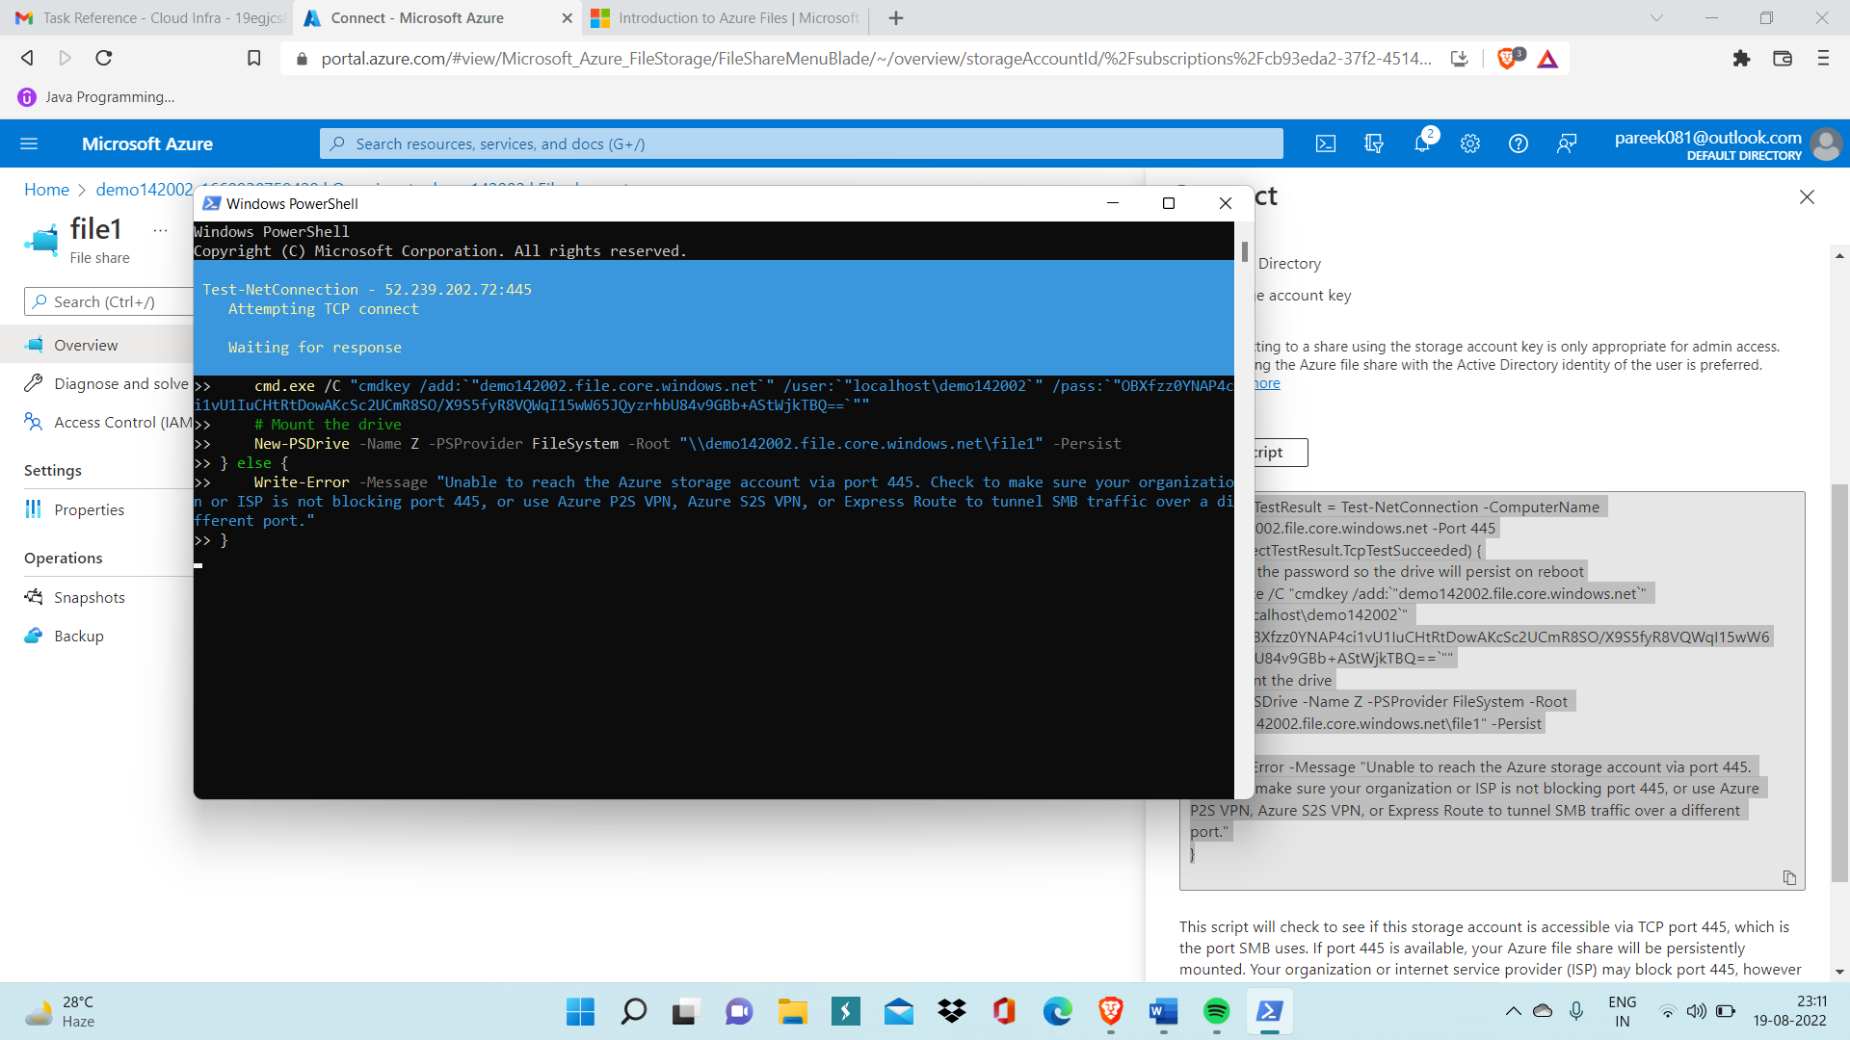

Step 6: Now fileshare gets mounted on your local drive, you can easily verify by looking inside This Pc, You will find fileshare present along with other drives but make sure that fileshare will be inside Network locations.

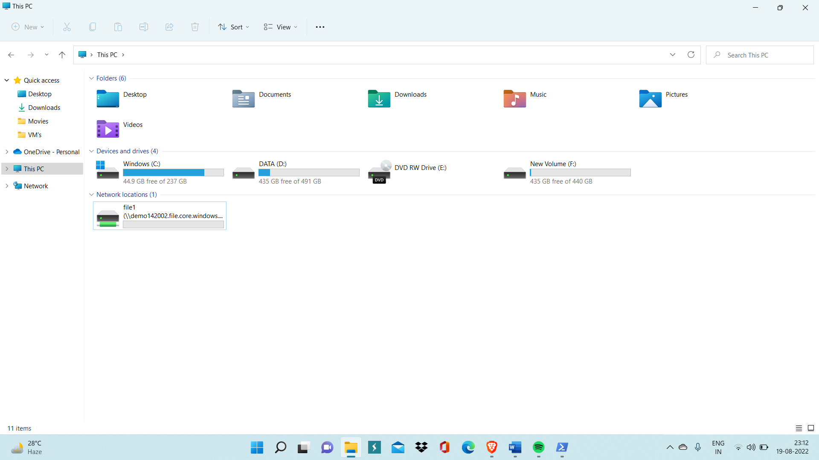

Step 7: Now to verify fileshare is correctly mounted on your local computer or not, Add file from Azure portal to file share which is present inside storage account you have already created.

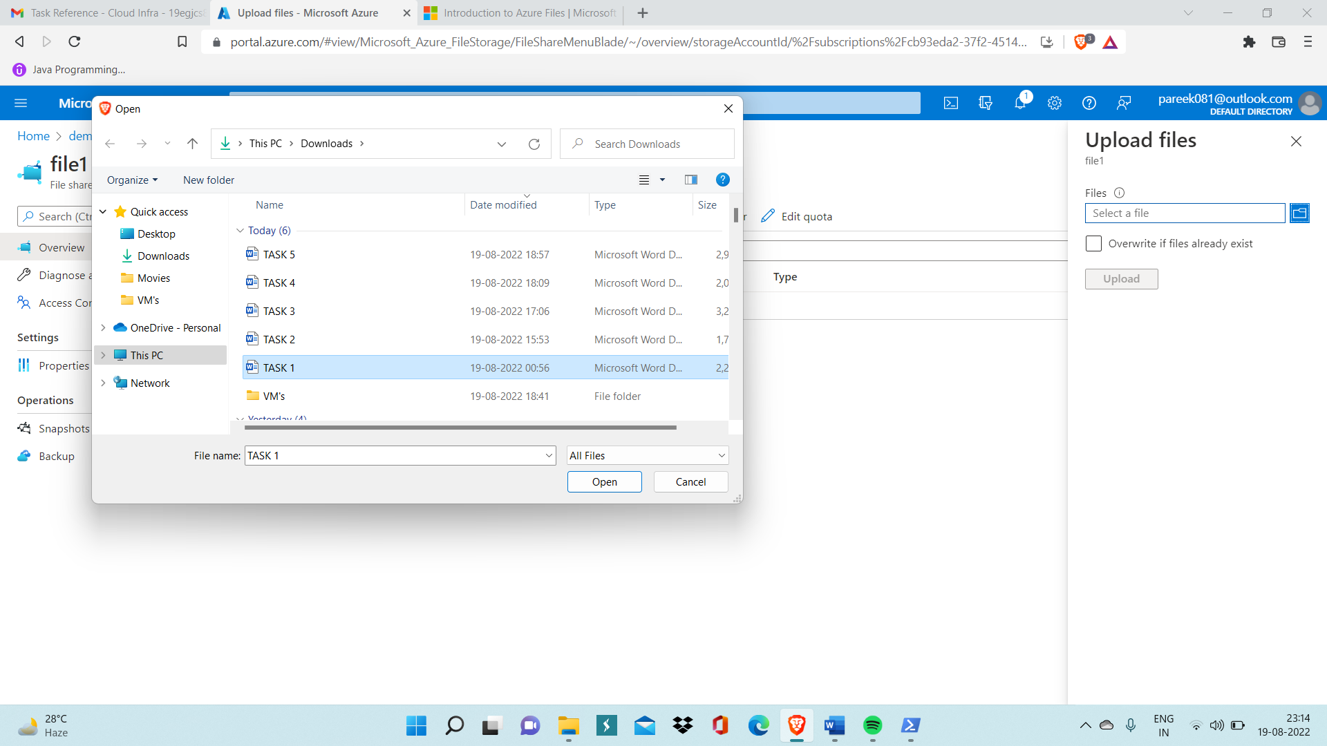

Step 8: Now go inside file1 drive present on your computer and if you find same file inside it that means fileshare is correctly mounted on your local computer.

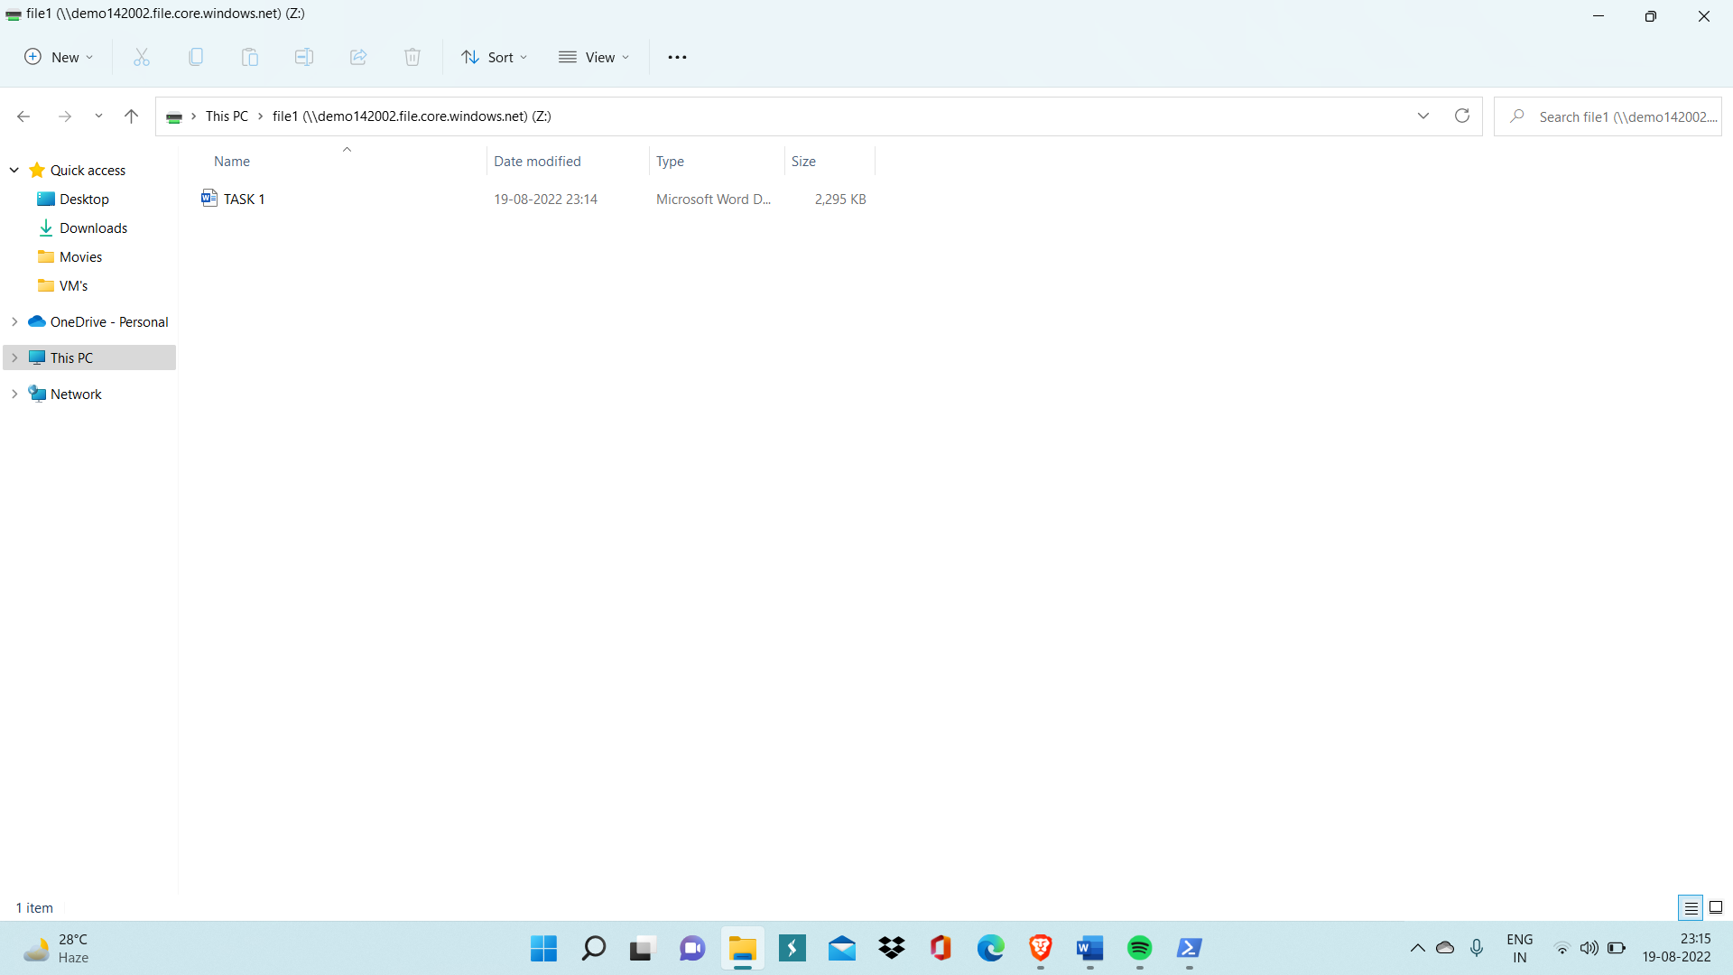

This shows fileshare is correctly mounted on local computer.